Observations on the DK test App

RED colour indicates that something needs to be changed int the App

Green colour indicates who will do it.

RAMA & AYUSH - PLEASE REPLY ON THIS DOCUMENT ONLY AFTER DOING ALL THE CHANGES AS I HAVE TOLD, BY INDICATING AGAINST EACH POINT WHAT CHANGES HAVE BEEN DONE SO THAT WE DON’T MISS ANY POINT.

1. My overall view on seeing the App (First impression): P.S – My observations are in random order.
a. It is a good effort but I expected many things to be automatically taken care of which doesn’t require any special inputs from me,also the size of the App is tooooooo BIG, I have mentioned these in my detailed comments below.
b. The changes which I recommended yesterday have to be completed ASAP, I thought those changes would have been done by now.
c. CHAT BOT is really disappointing for many reasons which I have mentioned below, it seems chat bot was done in a hurry.

Detailed Observations

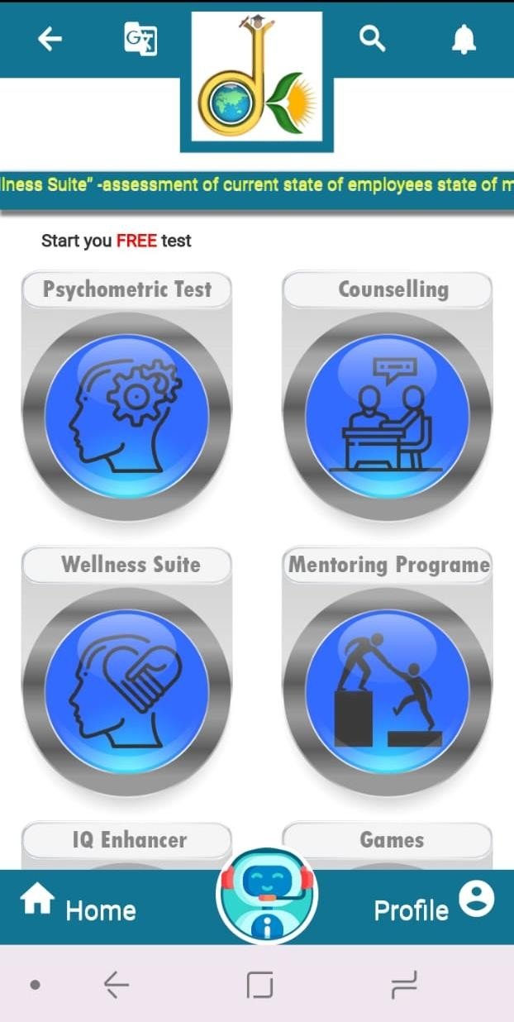1. On the main page of website and App, we have to put a link of government of India COVID19 information website link, this link shud not be active i.e is shud not work (bcos we don’t want people to leave our website and go) but it shud be there. I have shown below where to put the link. Also, on both app and website, we must have the following written on main page “Stay Safe, follow the Govt guidelines” , The link is https://www.mygov.in/covid-19 (Ayush & Rama)
2. For entering DOB – the year has to come by clicking on the month/year , as a drop down to choose the year of birth. As of now, a user has to click many many times to go to his year of birth month by month, I had to click 568 times to reach July 1972. THIS HAS TO BE CHANGED to make it easier for the user to be able to enter his DOB in a couple of seconds.(AYUSH)
3. The language button is not clear, a user can not understand what is this button for by just looking at it. THE ICON HAS TO CHANGE .(RAMA)
4. On clicking any language other than English the following Alert has to come :-

Languages other than “ENGLISH” will be available soon

(AYUSH)

5. While logging in , there should be no need to type the language, it must be a dropdown to select the language. (AYUSH)

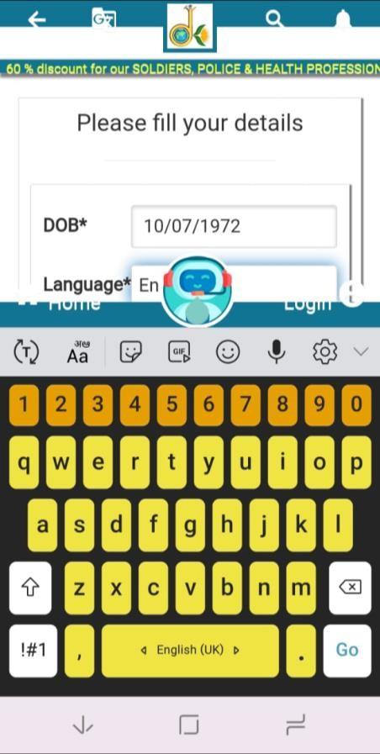While logging in the language option gets hidden by the screen bcos the keyboard comes up and the CHAT BOT obstructs the user to see whatever is being typed. (AYUSH)
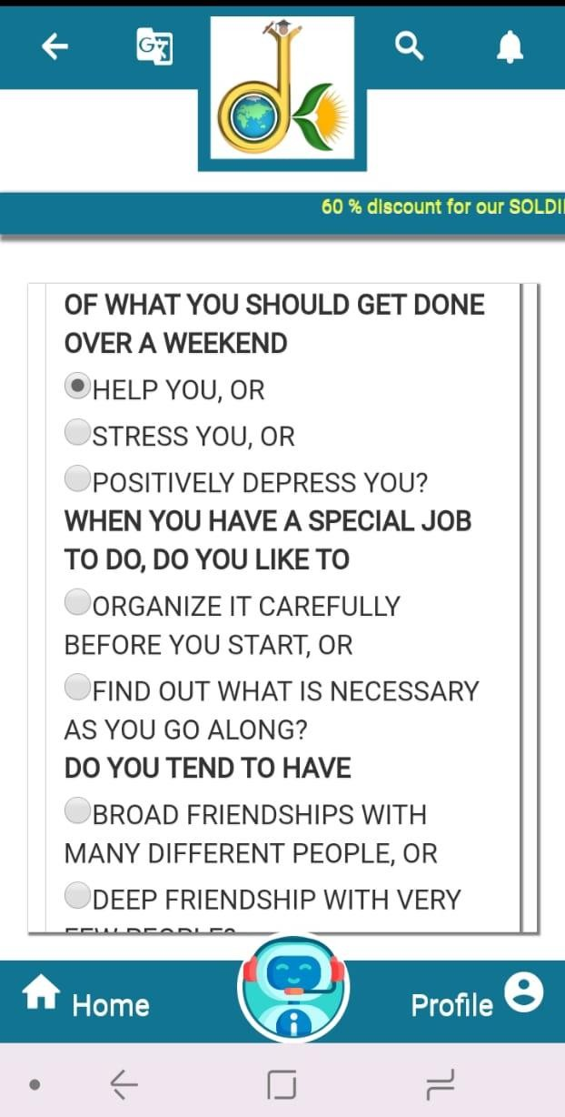6. The test page does not have question numbers, it must have numbers marked, like 1, 2 , 3, 4 …., and not PART2 etc. it is very difficult to differentiate between two questions, the user gets confused as to which is the question and there remains a doubt of the user has completed all the questions on that page. We can also try to put a thin line after every question. (AYUSH)
7.

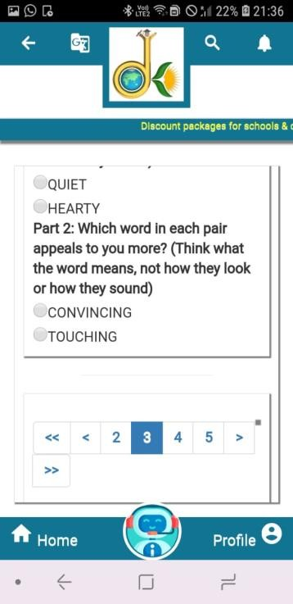8. When you click the next page, the next bottom of the next page appears, IT SHOULD BE THE TOP OF THE NEXT PAGE. When I clicked “3” after completing all questions on 2nd page, it took me to the bottom of 3rd page as shown below, whereas it shud take me to the top of third page. This is the case with all pages.(AYUSH)
9. SCREENSHOT OPTION HAS TO BE DISABLED FOR THE WHOLE APP, this means no User shud be able to take a screen shot of any page on the app. (AYUSH)
10. Why are you asking for phone number and email on the payment page, this has to be asked during logging in or in the case of guest users once the payment has been made but before giving the full results. (AYUSH)
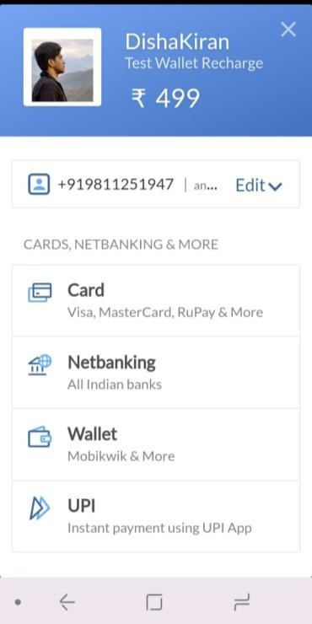11. In payment gateway there is no PayTM and other payment options? PayTM has to be on the main page of the gateway and it shud be clearly visible bcos the user needs to see all possible options at a glance and not on clicking another button. Lots of people don’t know what is a wallet. (AYUSH)

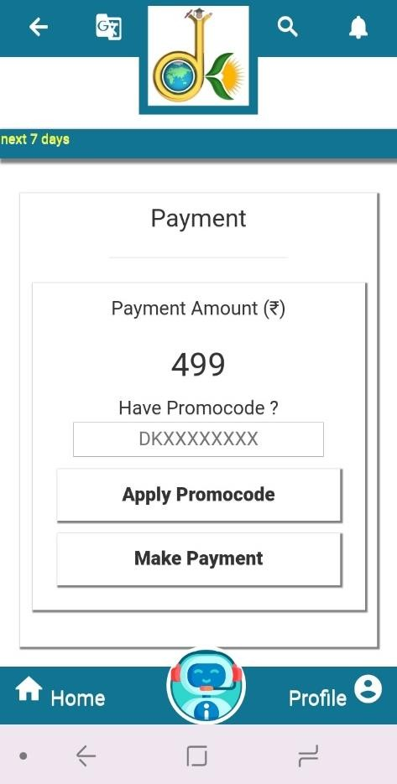12. On the payment no home, profile, language, search to be visible,only notification shud be visible so that the user can see the promocode there and ON MANY PAGES THERE ARE LINES VISIBLE WHICH LOOK VERY AWKWARD, REMOVE THESE LINES FROM WHICHEVER PAGE THEY ARE VISIBLE. The lines visible in green circles are Ok, the lines visible in red circles to be removed.
13. Notification has to come the moment app is opened and it will say “ congratulations, you can avail FLAT 20% inaugural discount by using promocode DKLAUNCH20. (AYUSH)

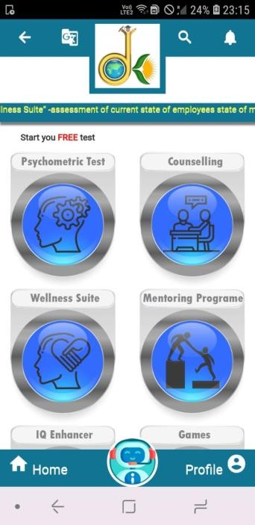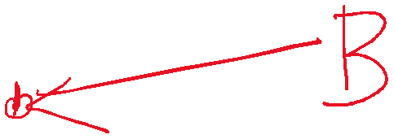

14. My history is giving the following error. Kindly correct this error. (AYUSH)
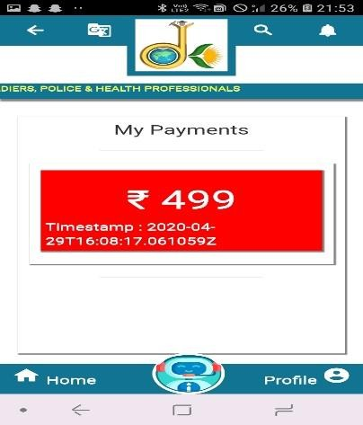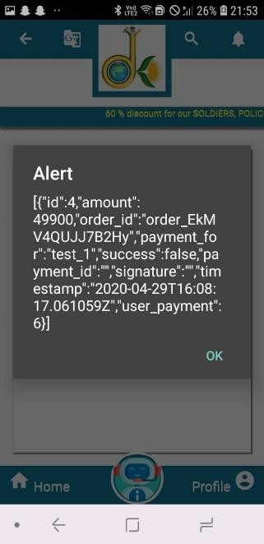

15. “My payment” is showing 499 whereas I haven’t made any payment.There is some error in the linking. (AYUSH)
16. The date format will be dd/mm/yy CHANGE IT. (AYUSH)
fo
r
ev
ery
thi
n
g
o
n
D
K
ap
17. The moment I log in with my details, the welcome email and sms and notification must immediately go to email, phone and app(notifications) respectively. It is not happening now. (AYUSH)
p
.
SO
18. Chat bot text is not proper, see it below, it has to be properly aligned (Justify), also the font size has to be increased. (AYUSH)

19. Wherever there is discount and % of discount , it has to be in BOLD. (AYUSH)
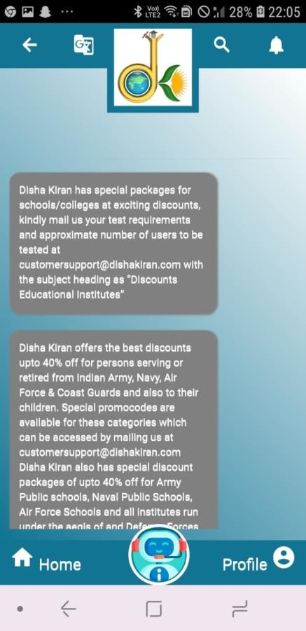20. Wherever we have given info@dishakiran.com and customersupport@dishakiran.com , these should be direct links to go to their email so that they can send us the mail directly by clicking on our links. (AYUSH)
21. In chat bot, 2 answers should never be allowed to be seen together, see below. People should either see the army discount or school discount on the same page, so when one quesry is clicked , the other answer shud vanish. (AYUSH)
22. Spelling mistakes in customersupport@dishakiran.com of defence discount(RAMA)
23. DK app shud not close by pressing “back” only once from home page or from anywhere. It should take 2 times click on back for app to close and before closing the app, following message shud come “. (AYUSH)
“ Are you sure you want to close the App, the Launch discount is available only now, we recommend you avail the discount “
24. Once a user is logged in , after X minutes of no activity, the user shud be automatically logged out? (AYUSH)
25. Have minimum gap between”Personality & Interest Assessment” and the first line of instructions. (AYUSH)
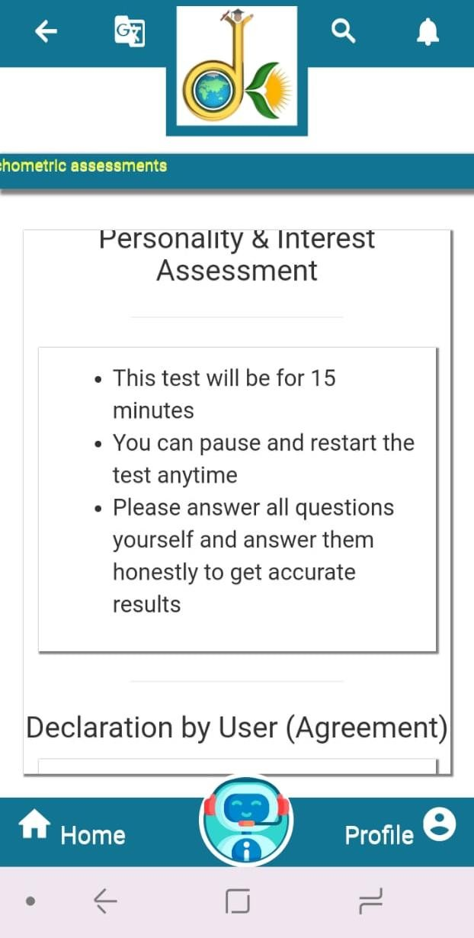




26. Have minimum gap between the last line of instructions and “Declaration by User”. (AYUSH)

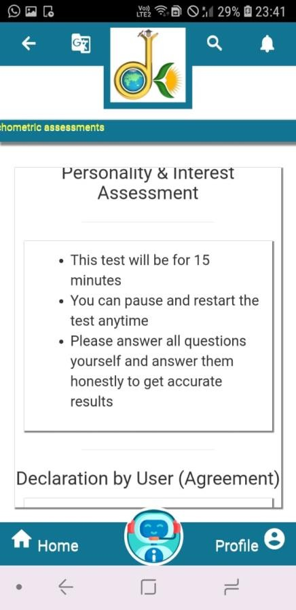
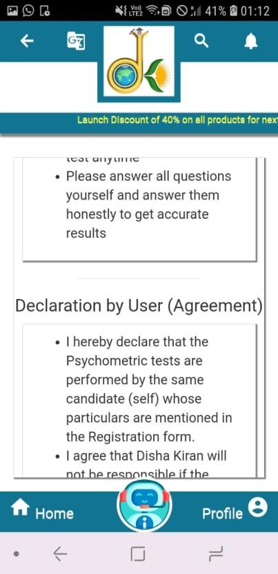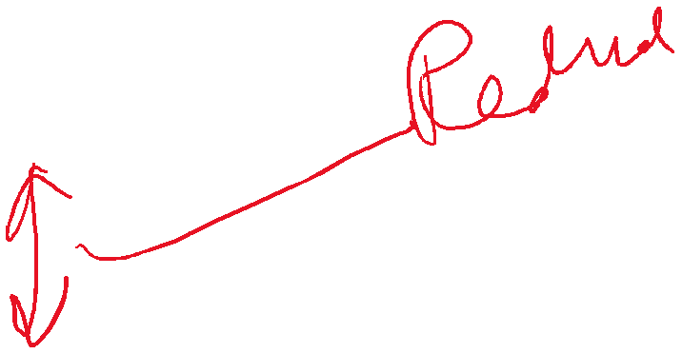27. Have smaller text font for User agreement on the first page of the test, also reduce the gap between the two lines to minimum so that the text occupies minimum vertical space. (AYUSH)

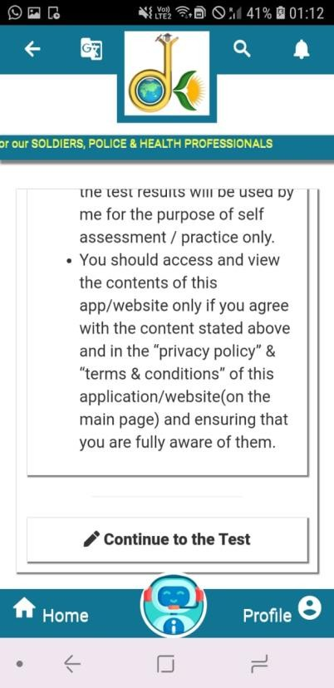

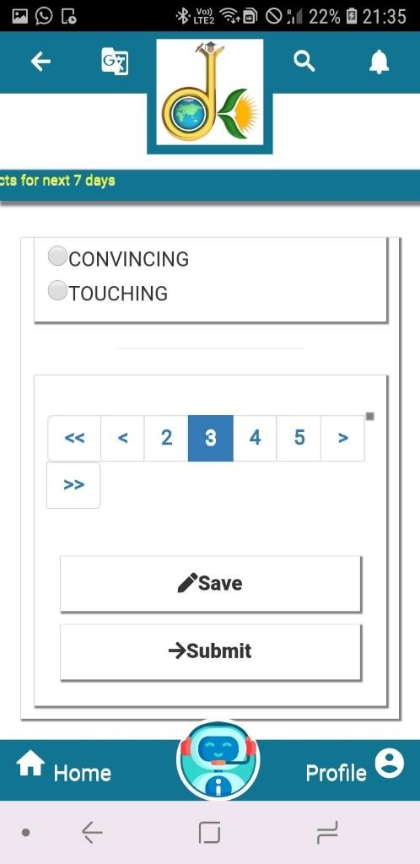28. There are far too many lines on the bottom of the first page of the test, looks very disorganised. (AYUSH)
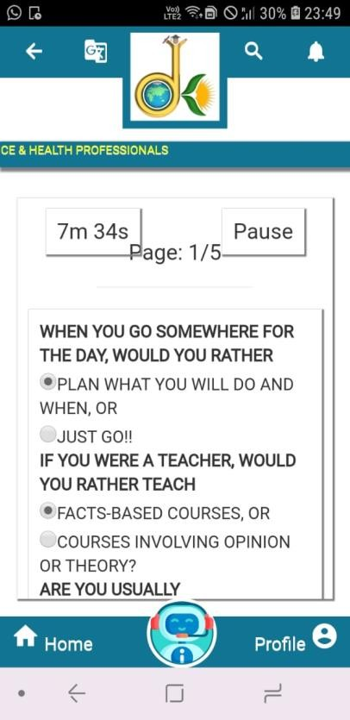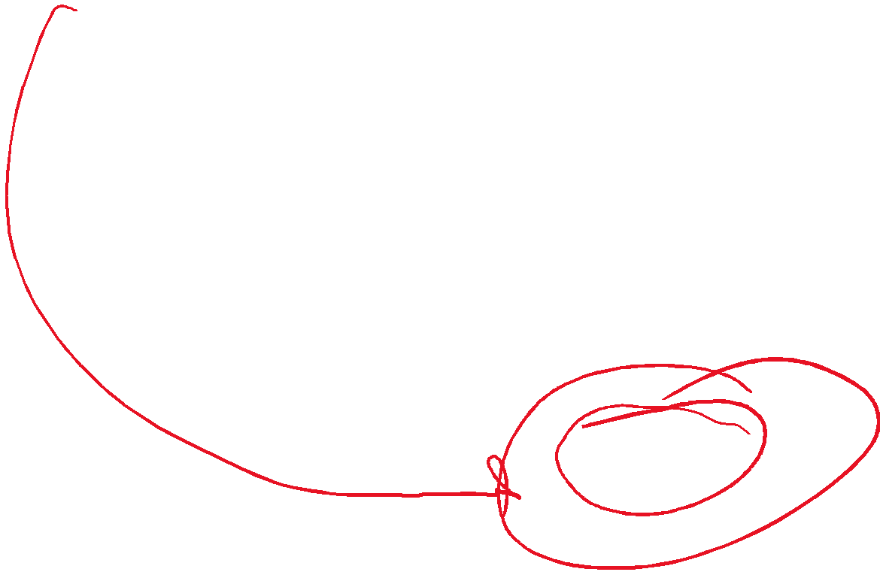29. On the test “Page 1/5” overlaps with the timer and the pause botton, it shud not be so. (AYUSH)

30. The Names of the six tests will be as given below: The text will be : (AYUSH & RAMA)
- Know your Personality & Interest
- Know your Aptitude/Intelligence
- Wellness Suite – Know your mind
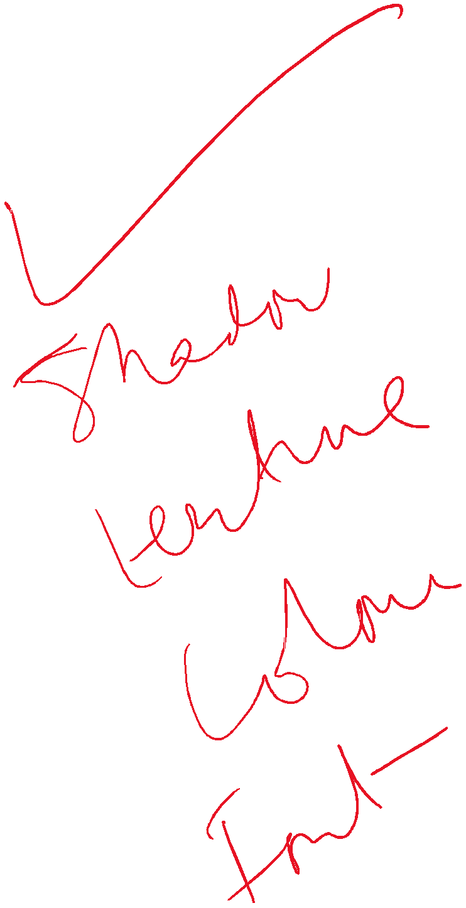- Find a Mentor to guide you
- Enhance your Gaming Skills
- Connect with a Counsellor

Know your
Personality & Interest

